Damien Bafile

M036449@tafe.wa.edu.au

Testing

Contents

Firefox 2

Load 2

Search Title 2

Search Genre with Rating in Year 2

Search Title with Genre 3

Movie Not Found 3

Incorrect Search 3

Top 10 Search Movies 4

EDGE 4

Search Genre with Rating in Year 5

Search Title with Genre 5

Movie Not Found 5

Incorrect Search 6

Top 10 Search Movies 6

Unexpected Behaviour? 7

Are Requirements Completed? 7

Security issues? 7

Adjustments from testing. 7

# Firefox

## Load

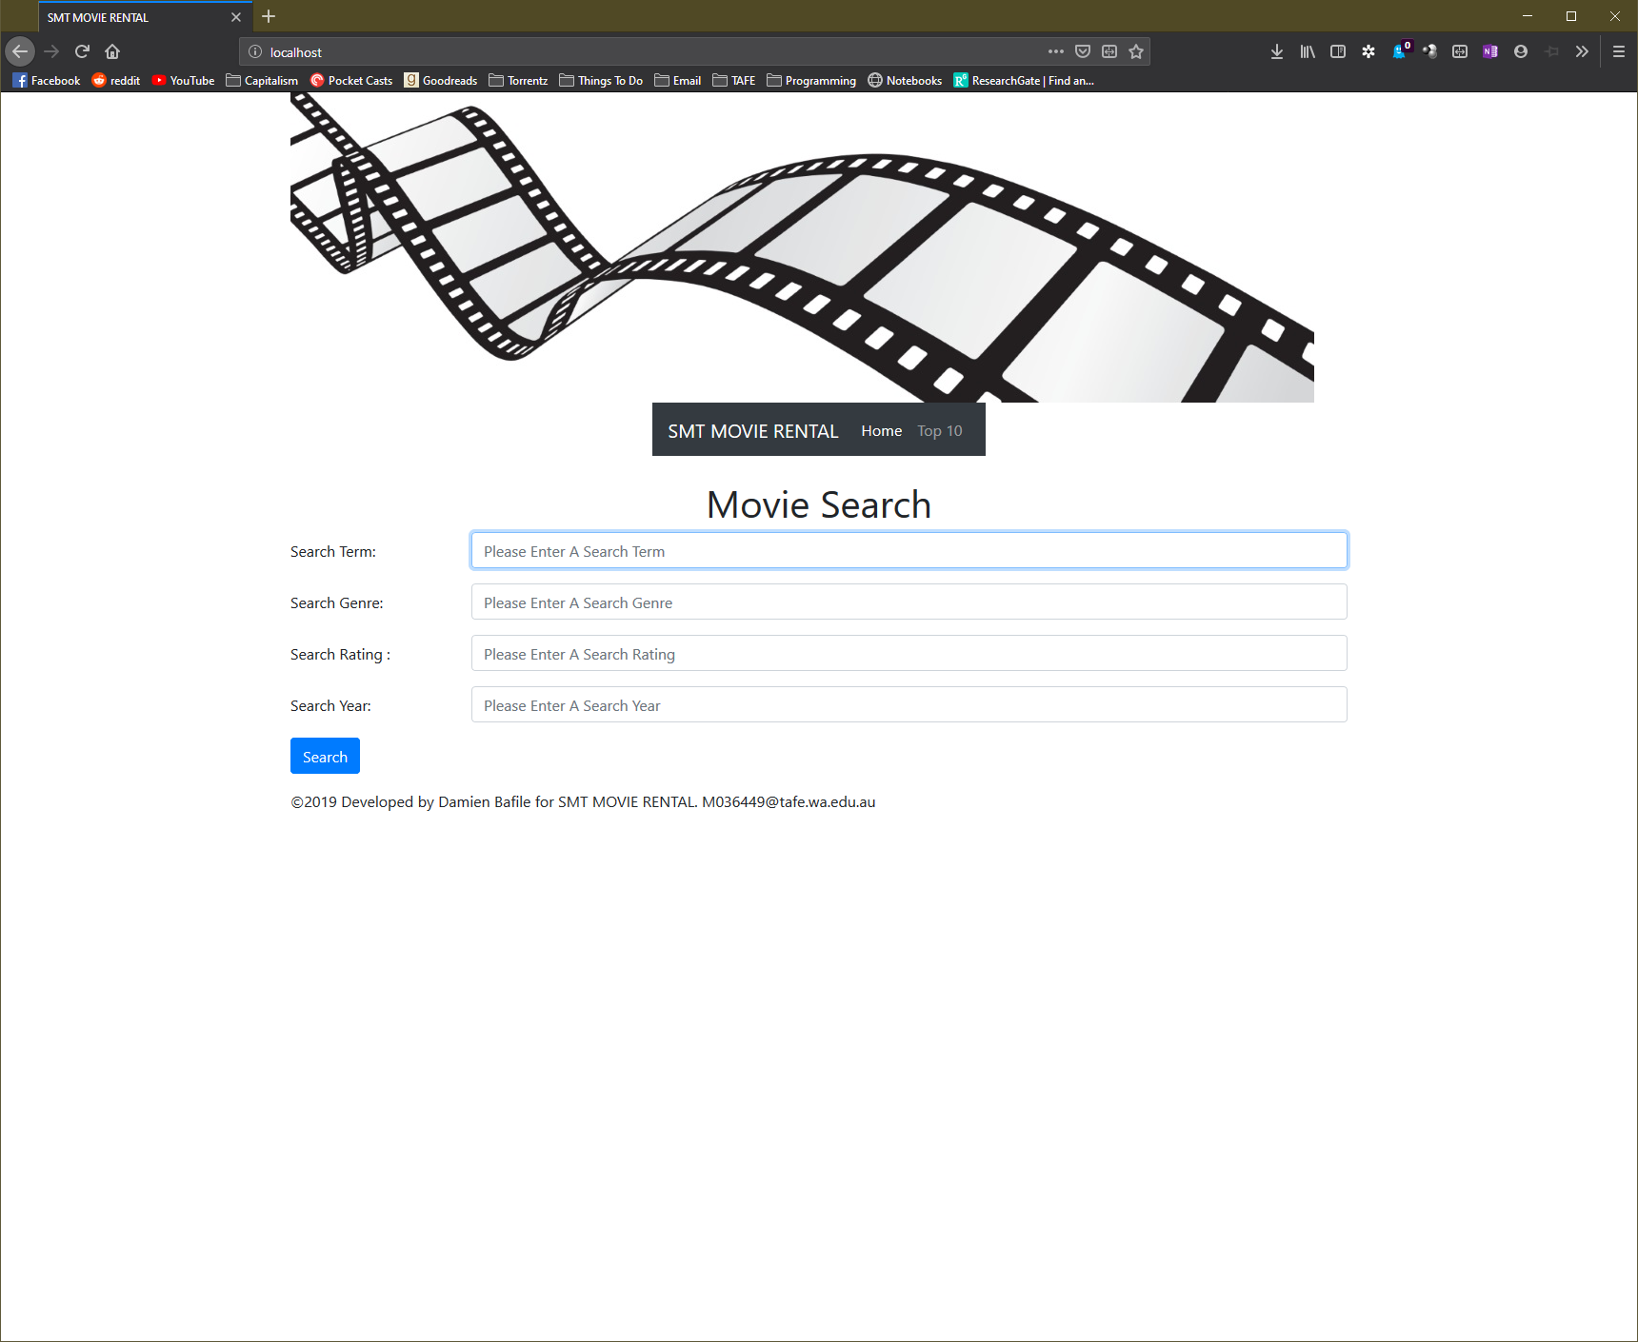

## Search Title

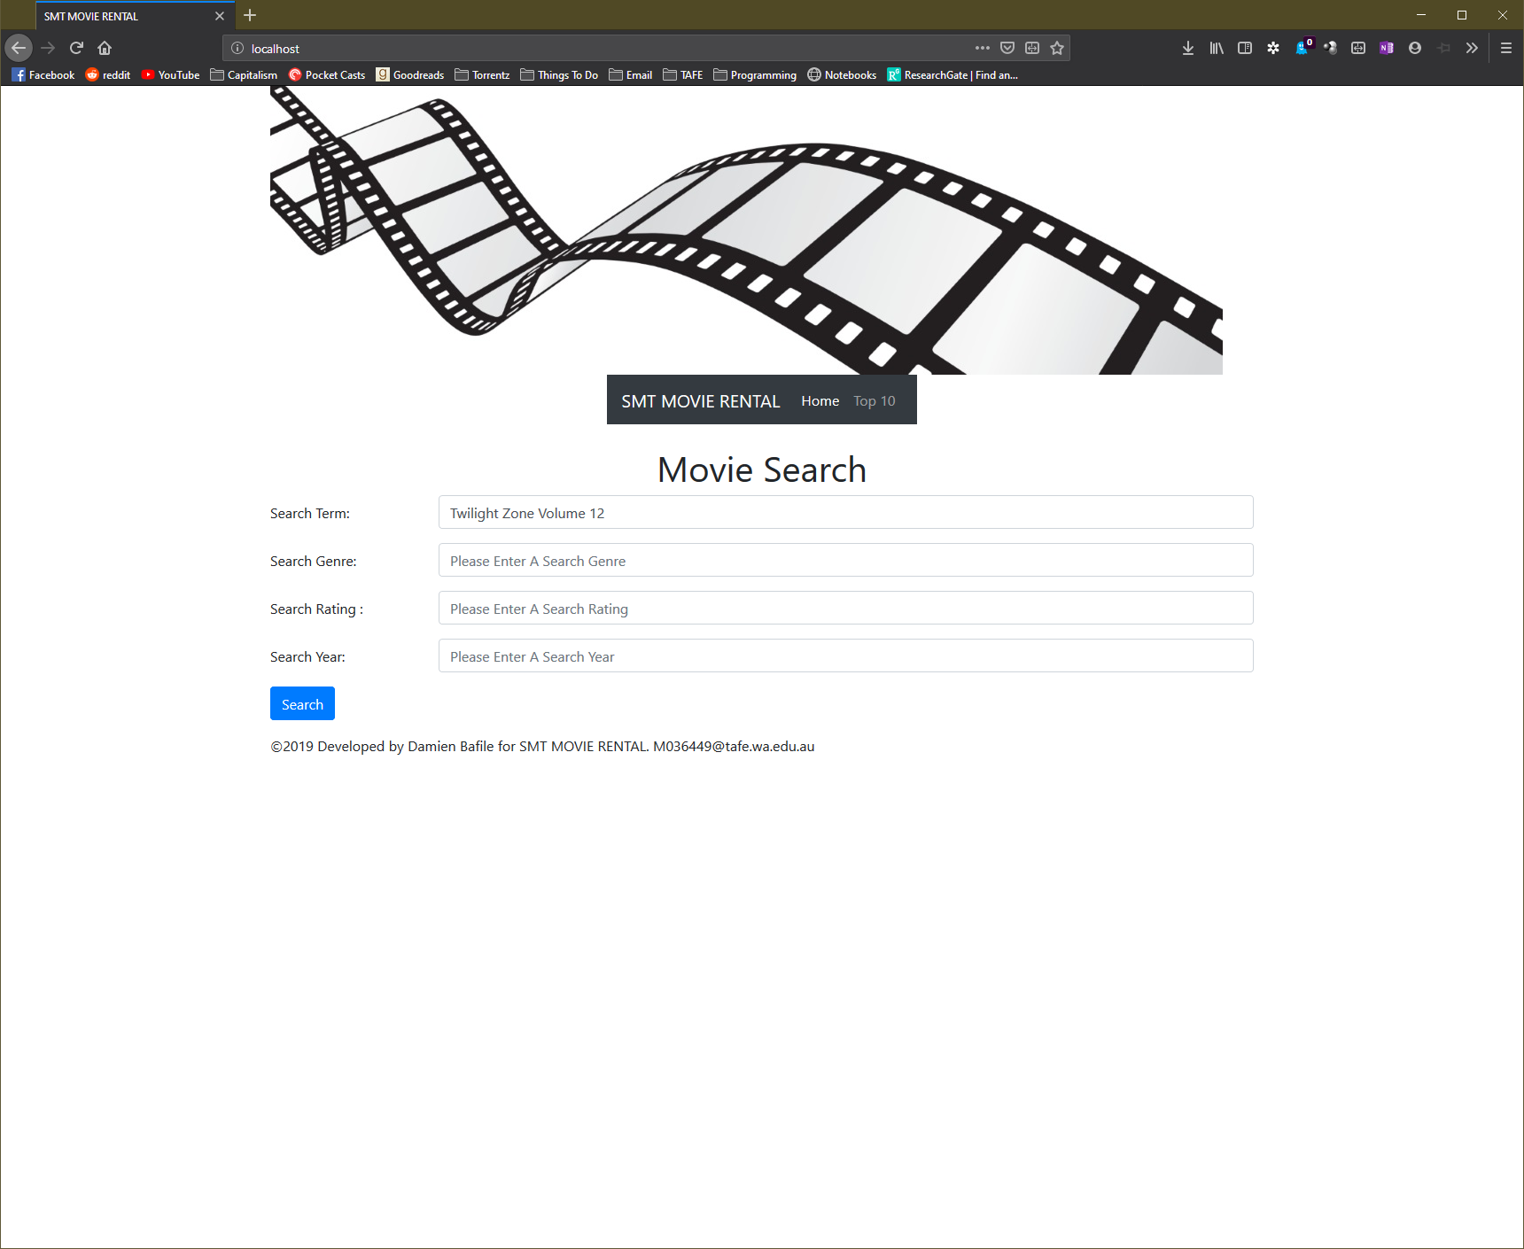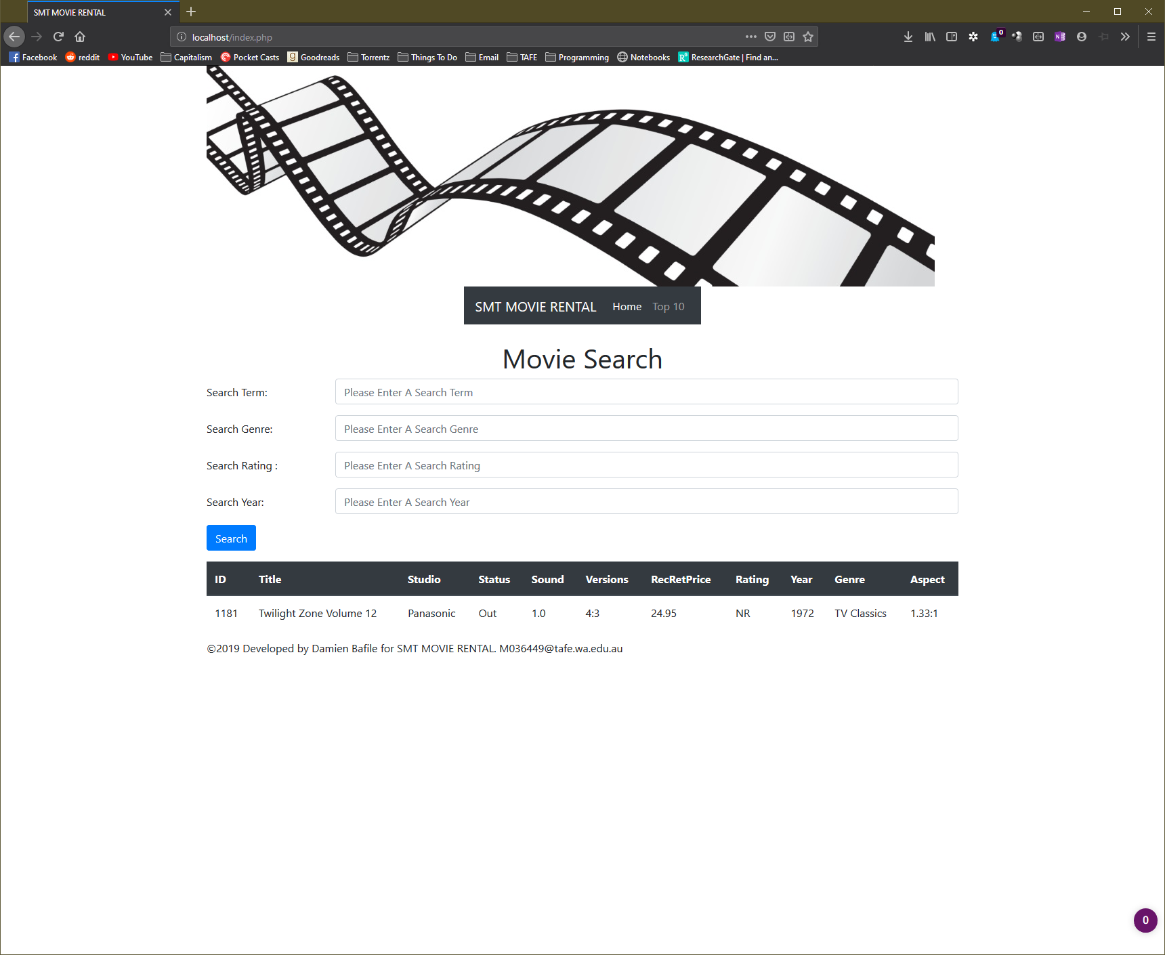

## Search Genre with Rating in Year

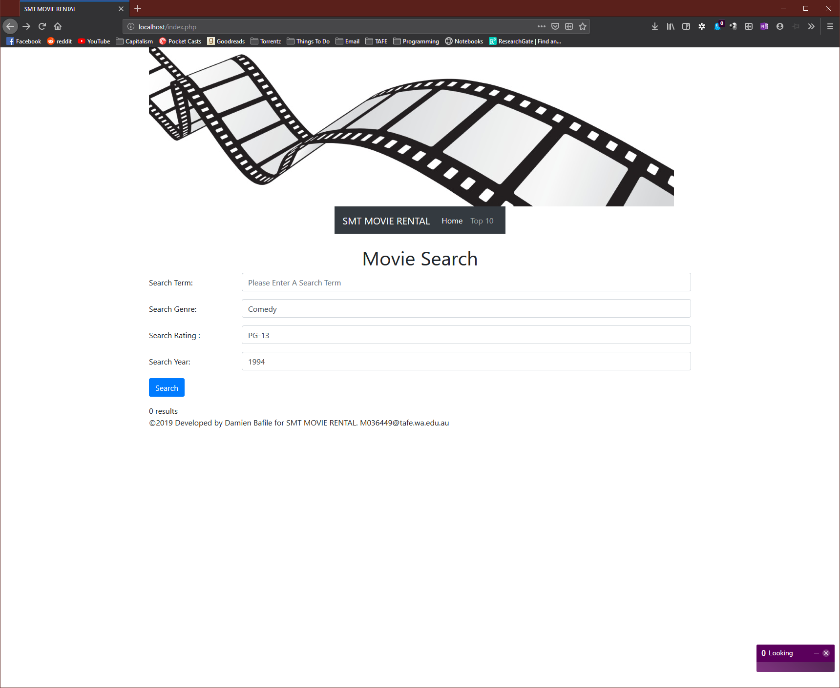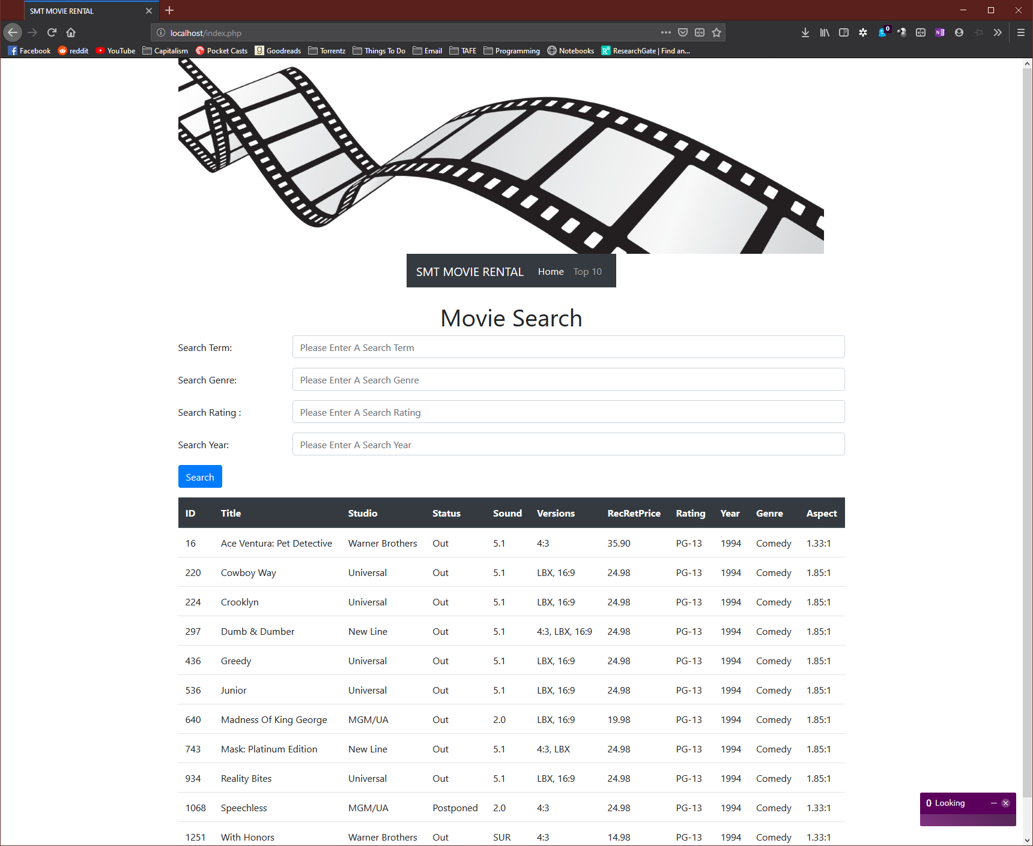

## Search Title with Genre

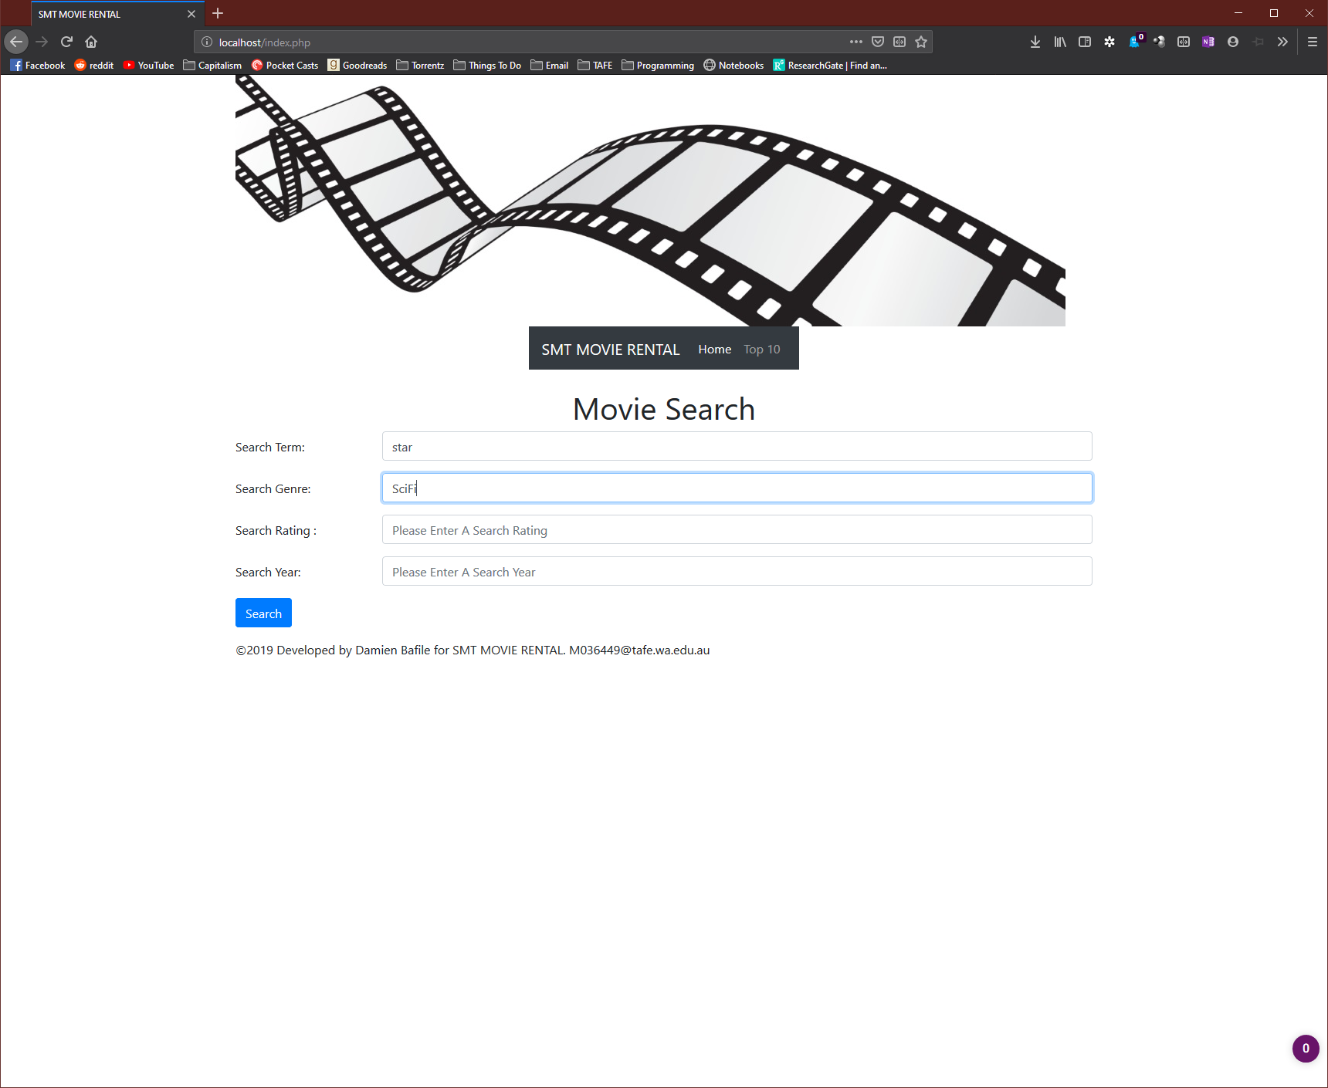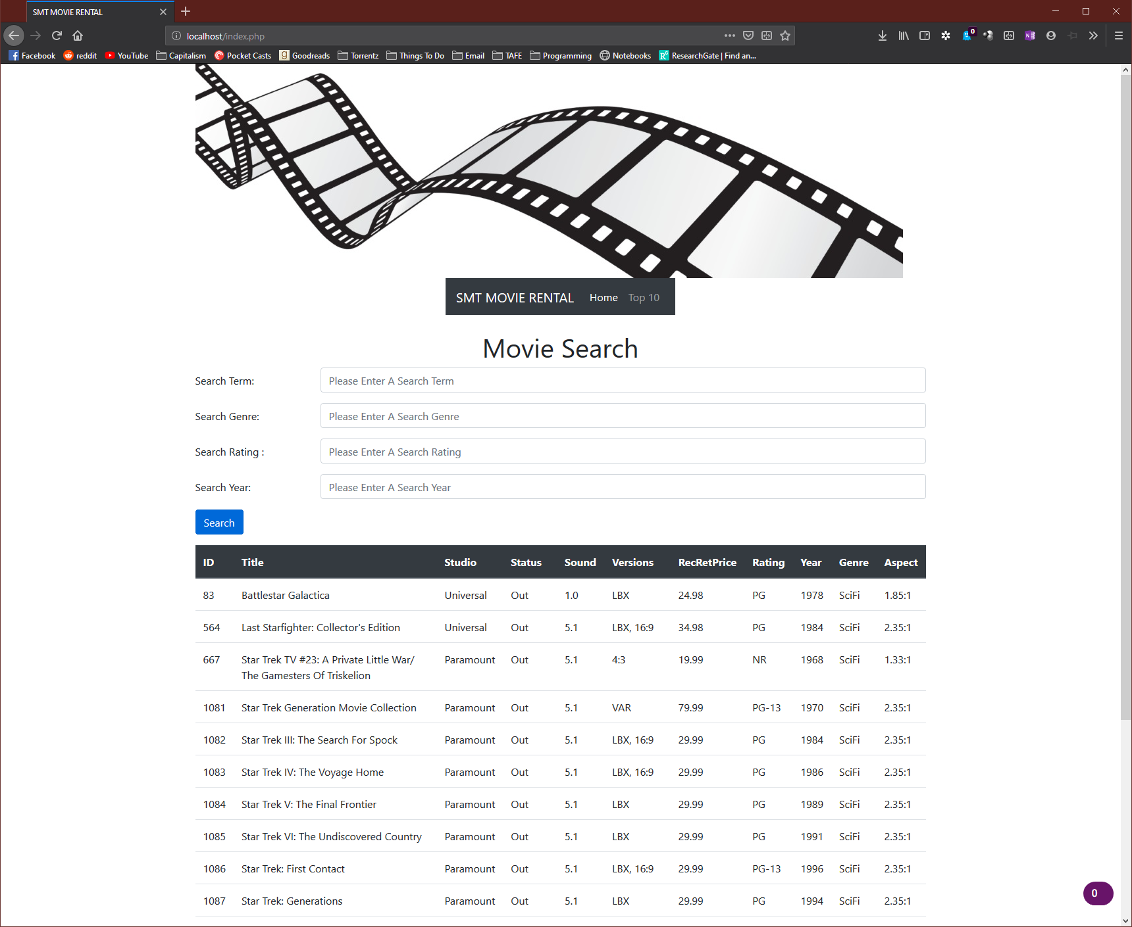

## Movie Not Found

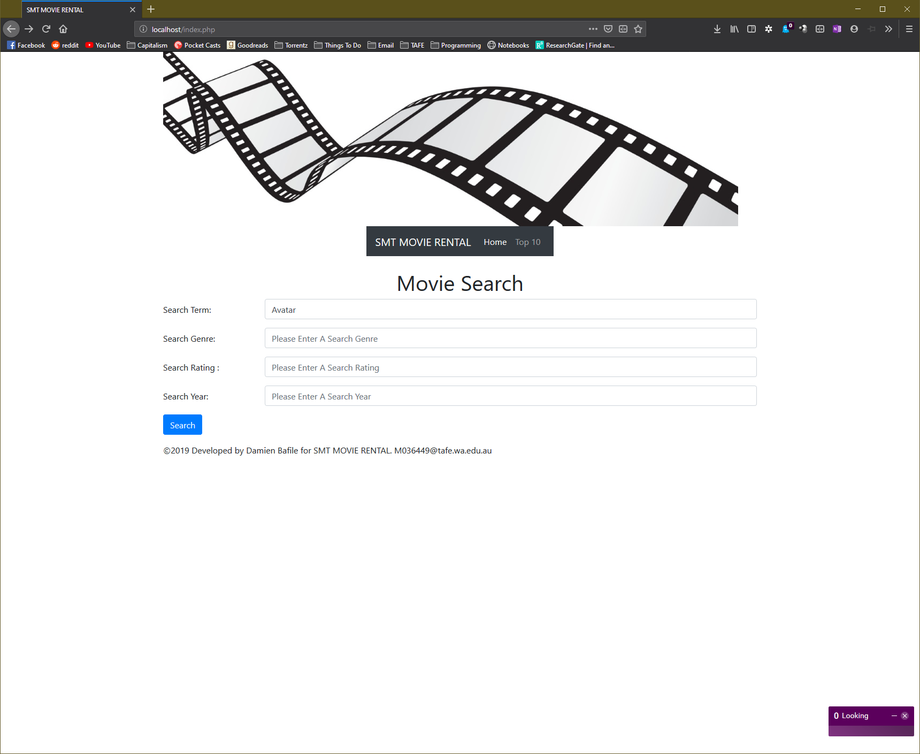 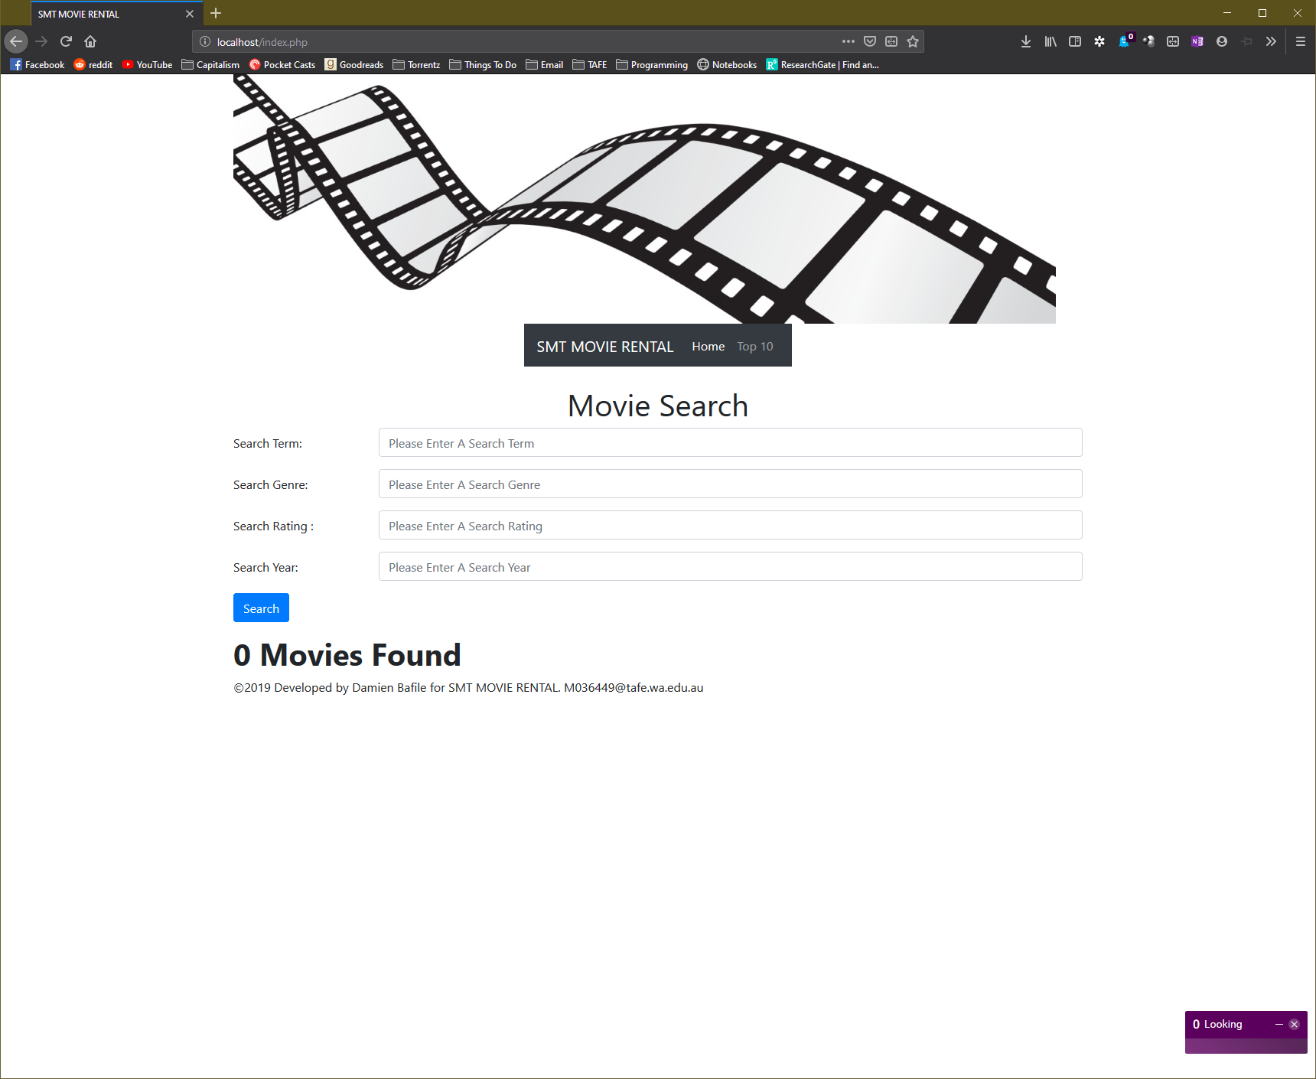

## Incorrect Search

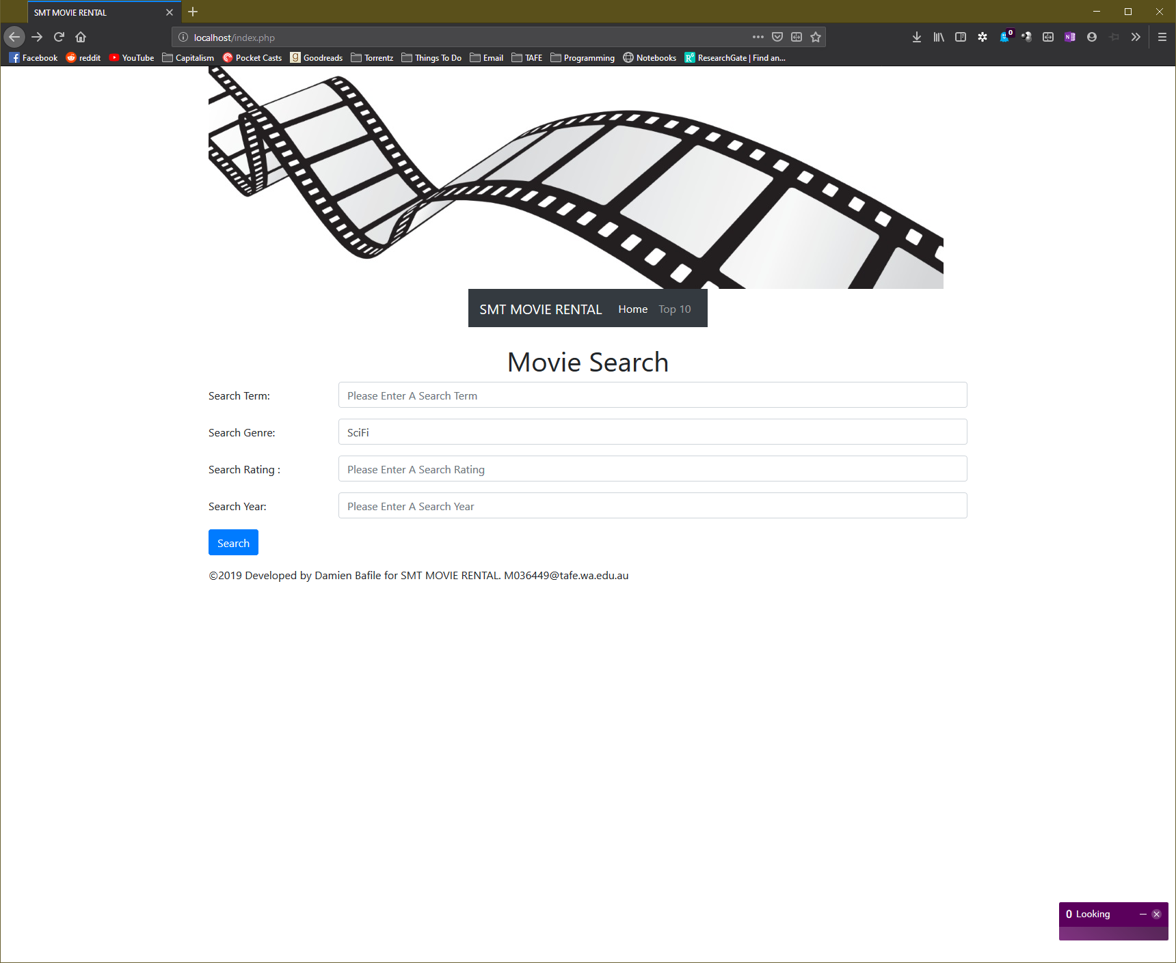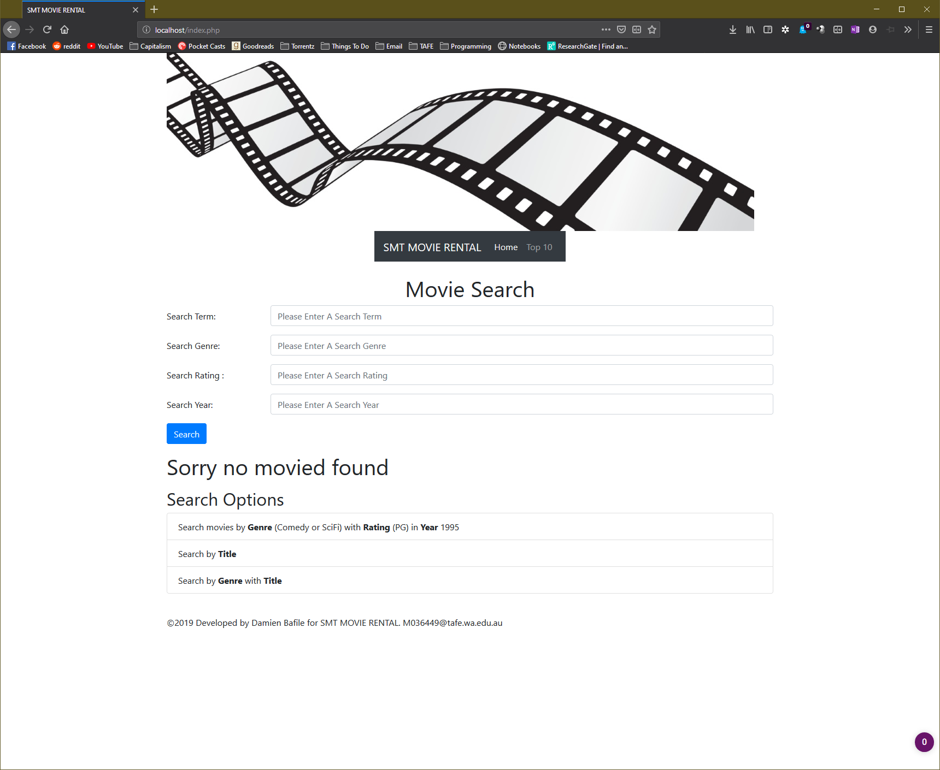

## Top 10 Search Movies

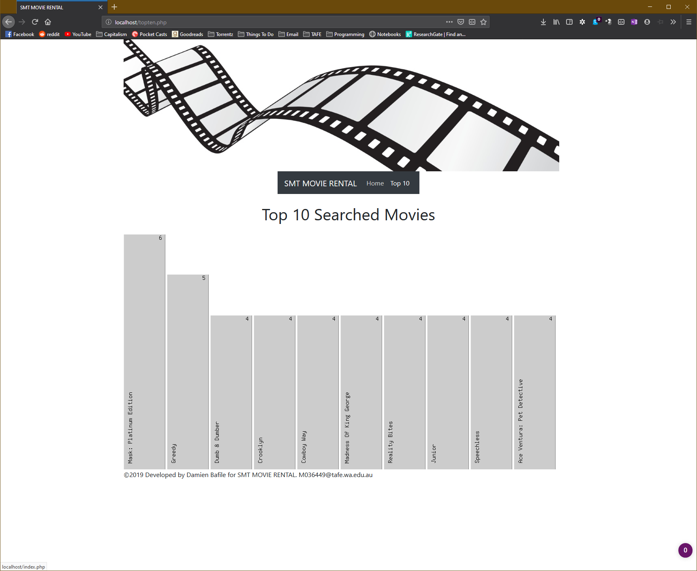

# EDGE

Load

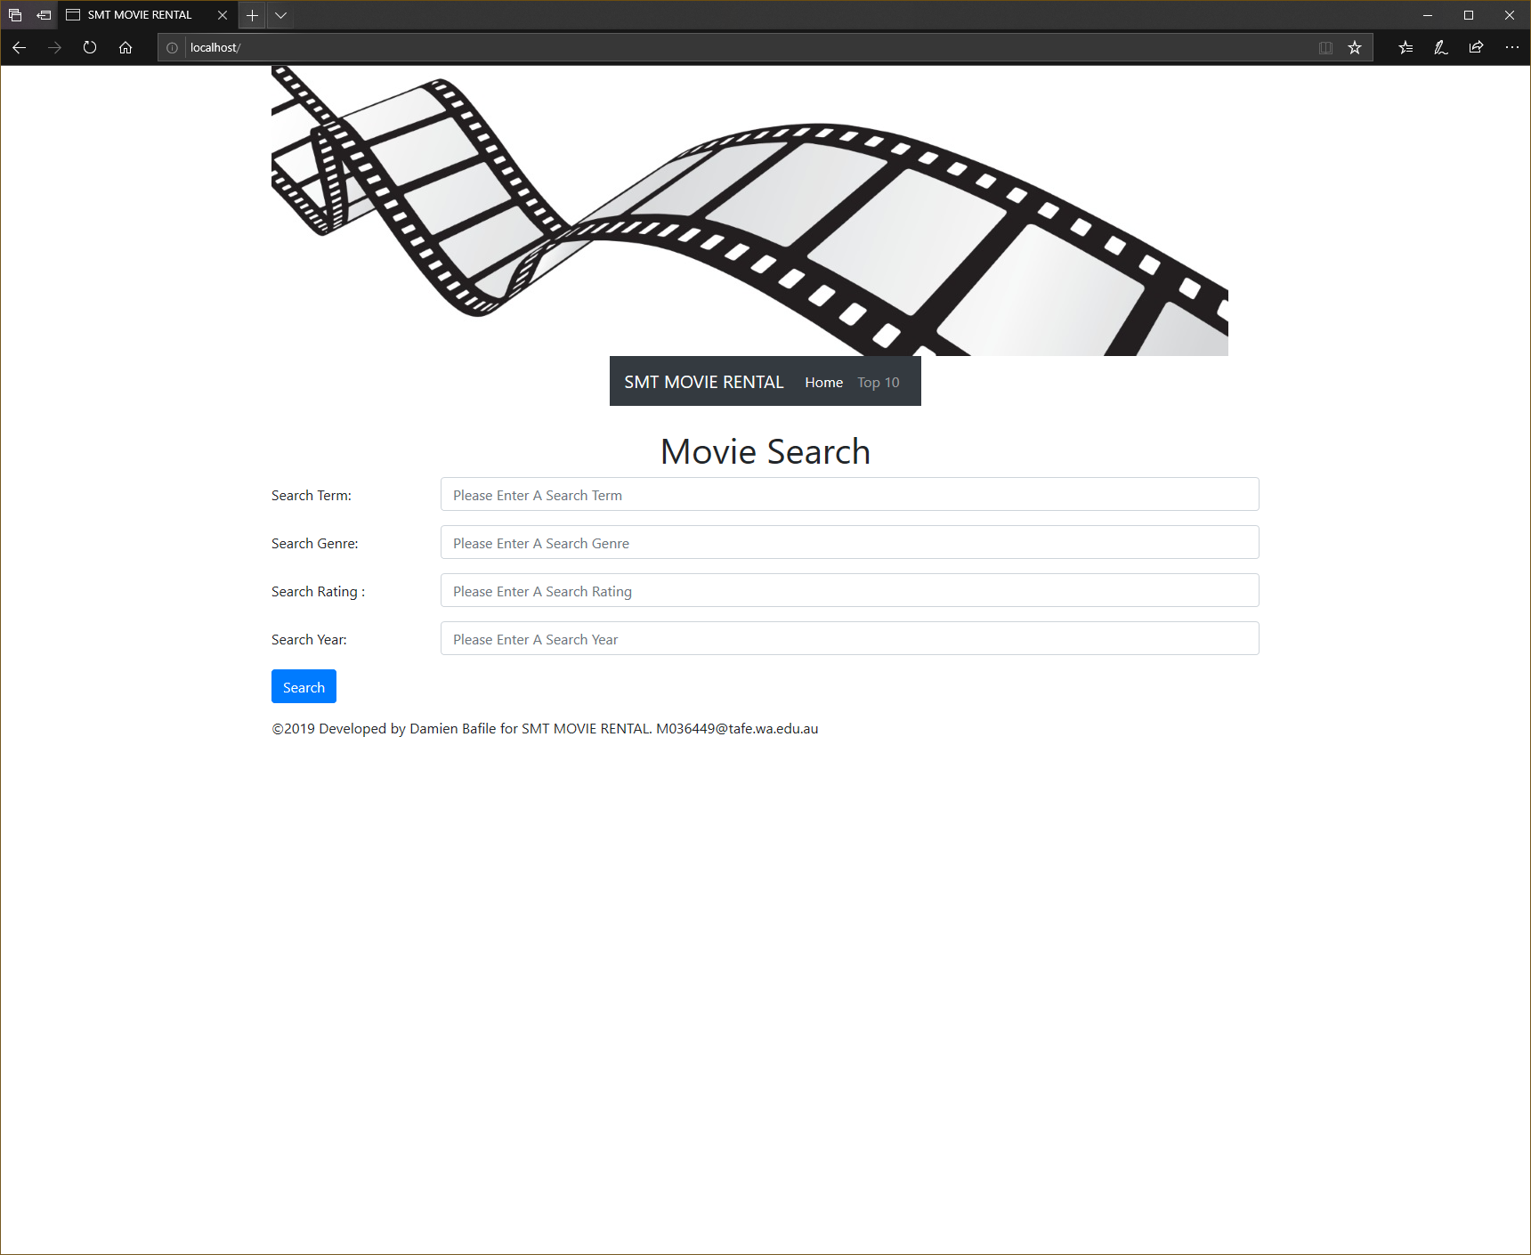

Search Title

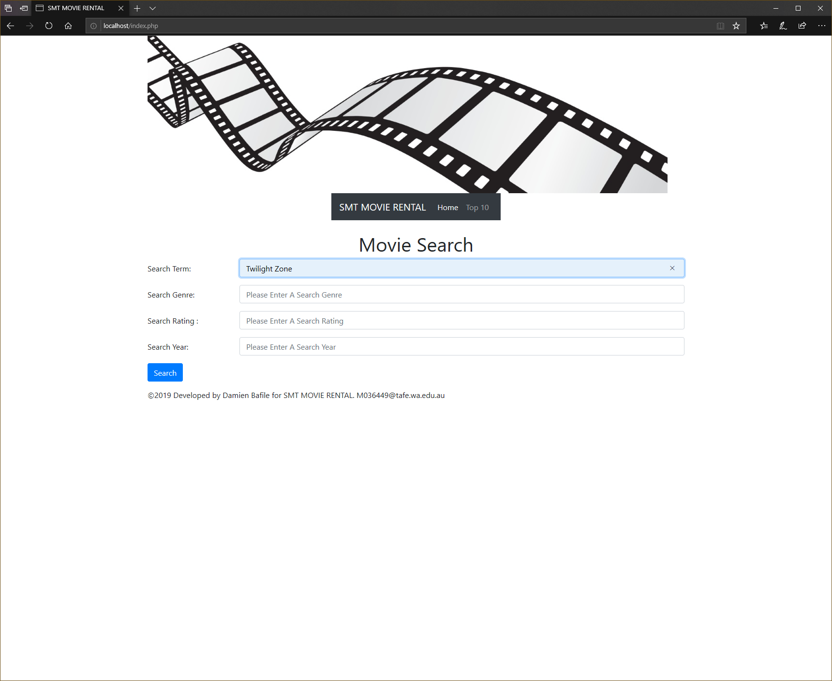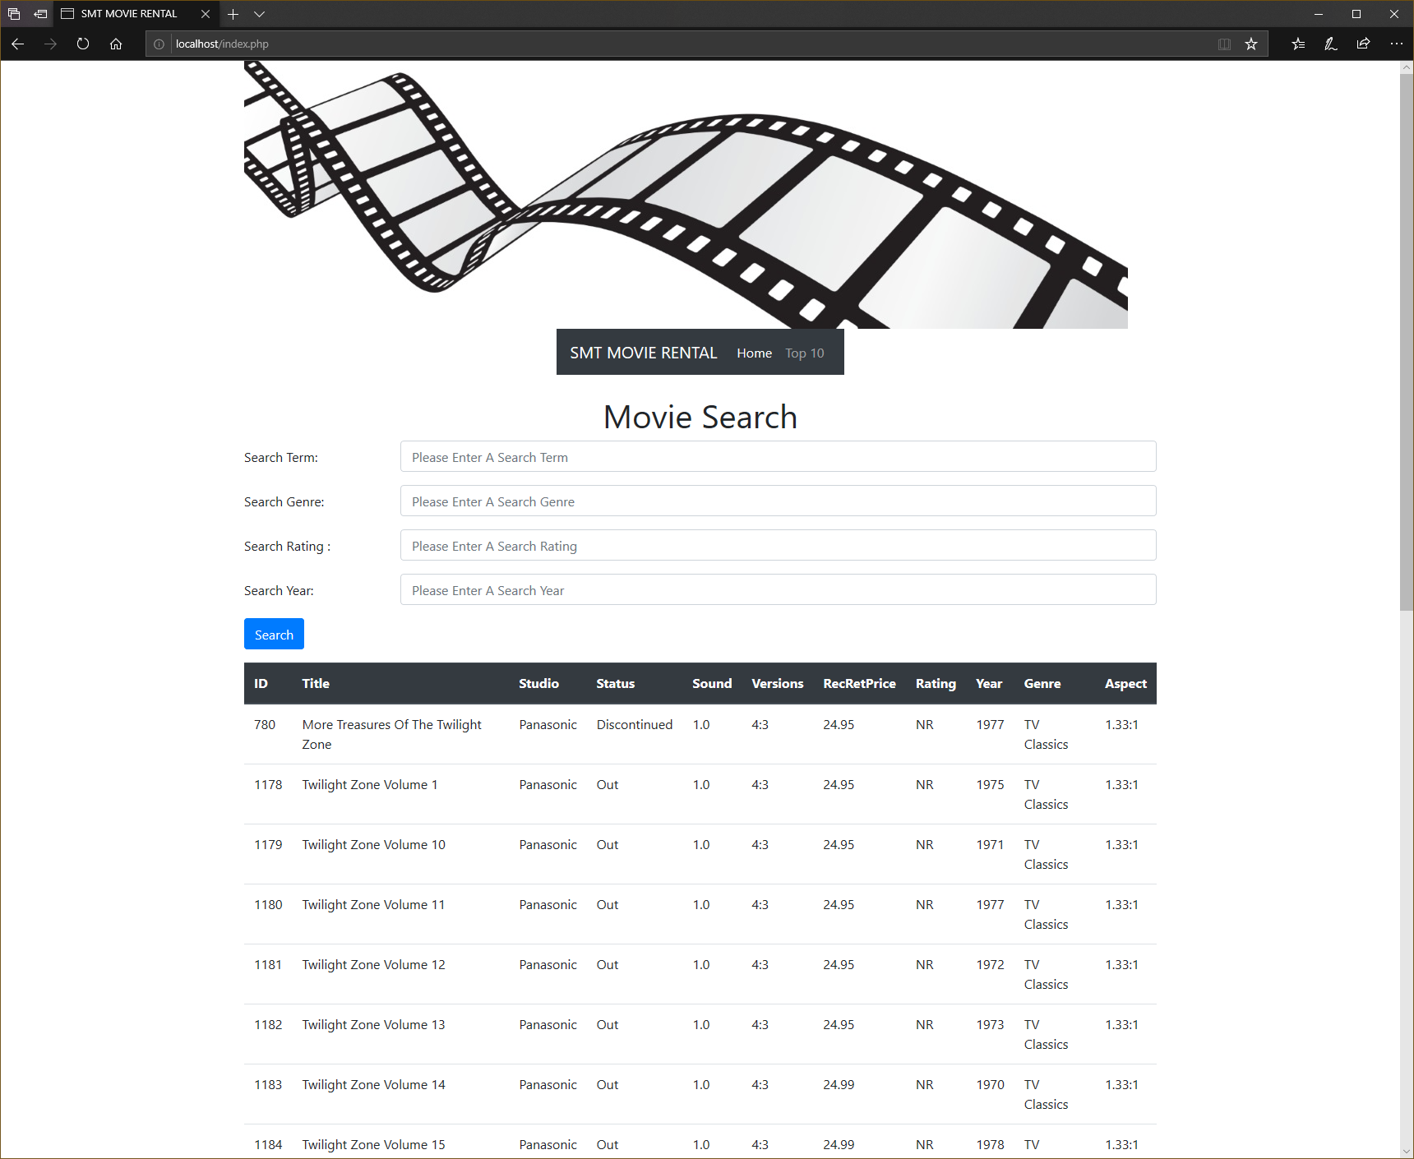

## Search Genre with Rating in Year

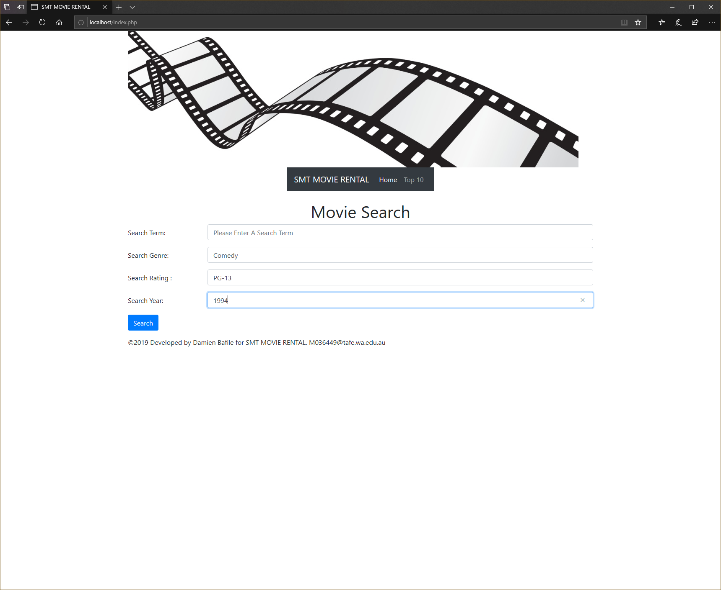 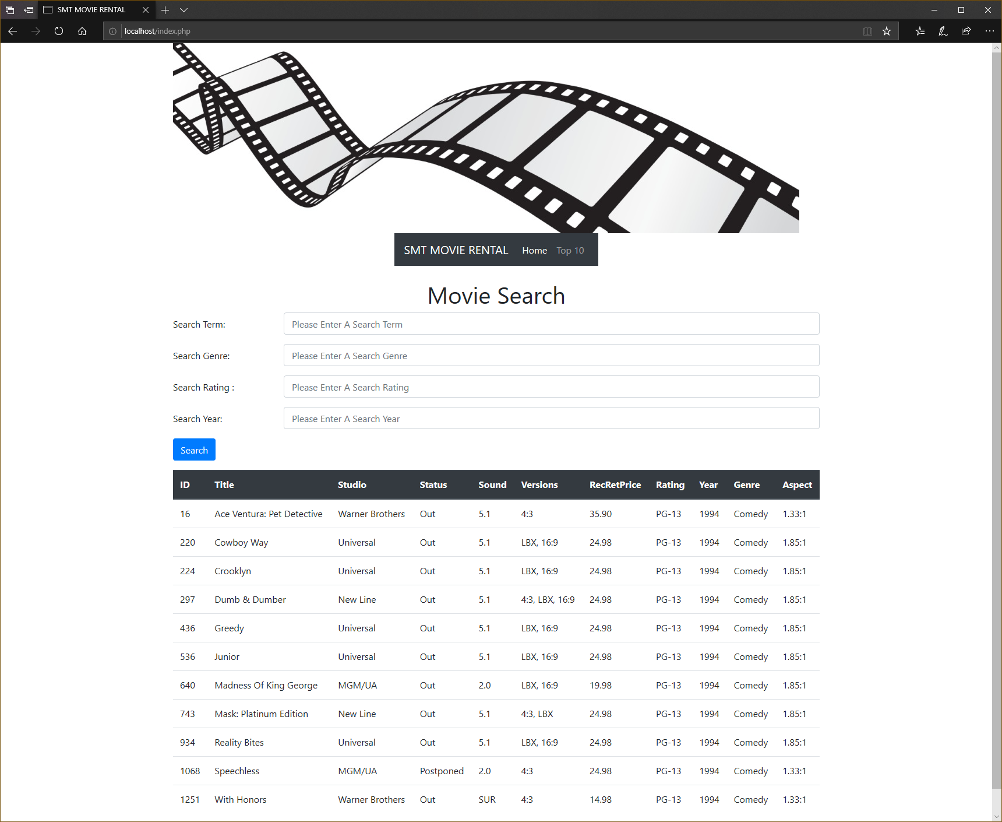

## Search Title with Genre

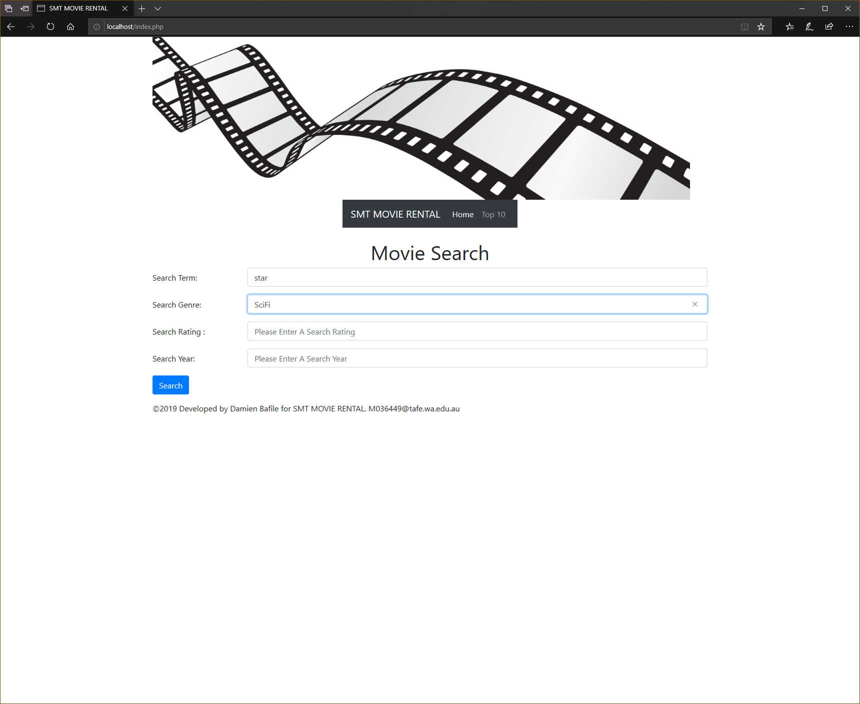 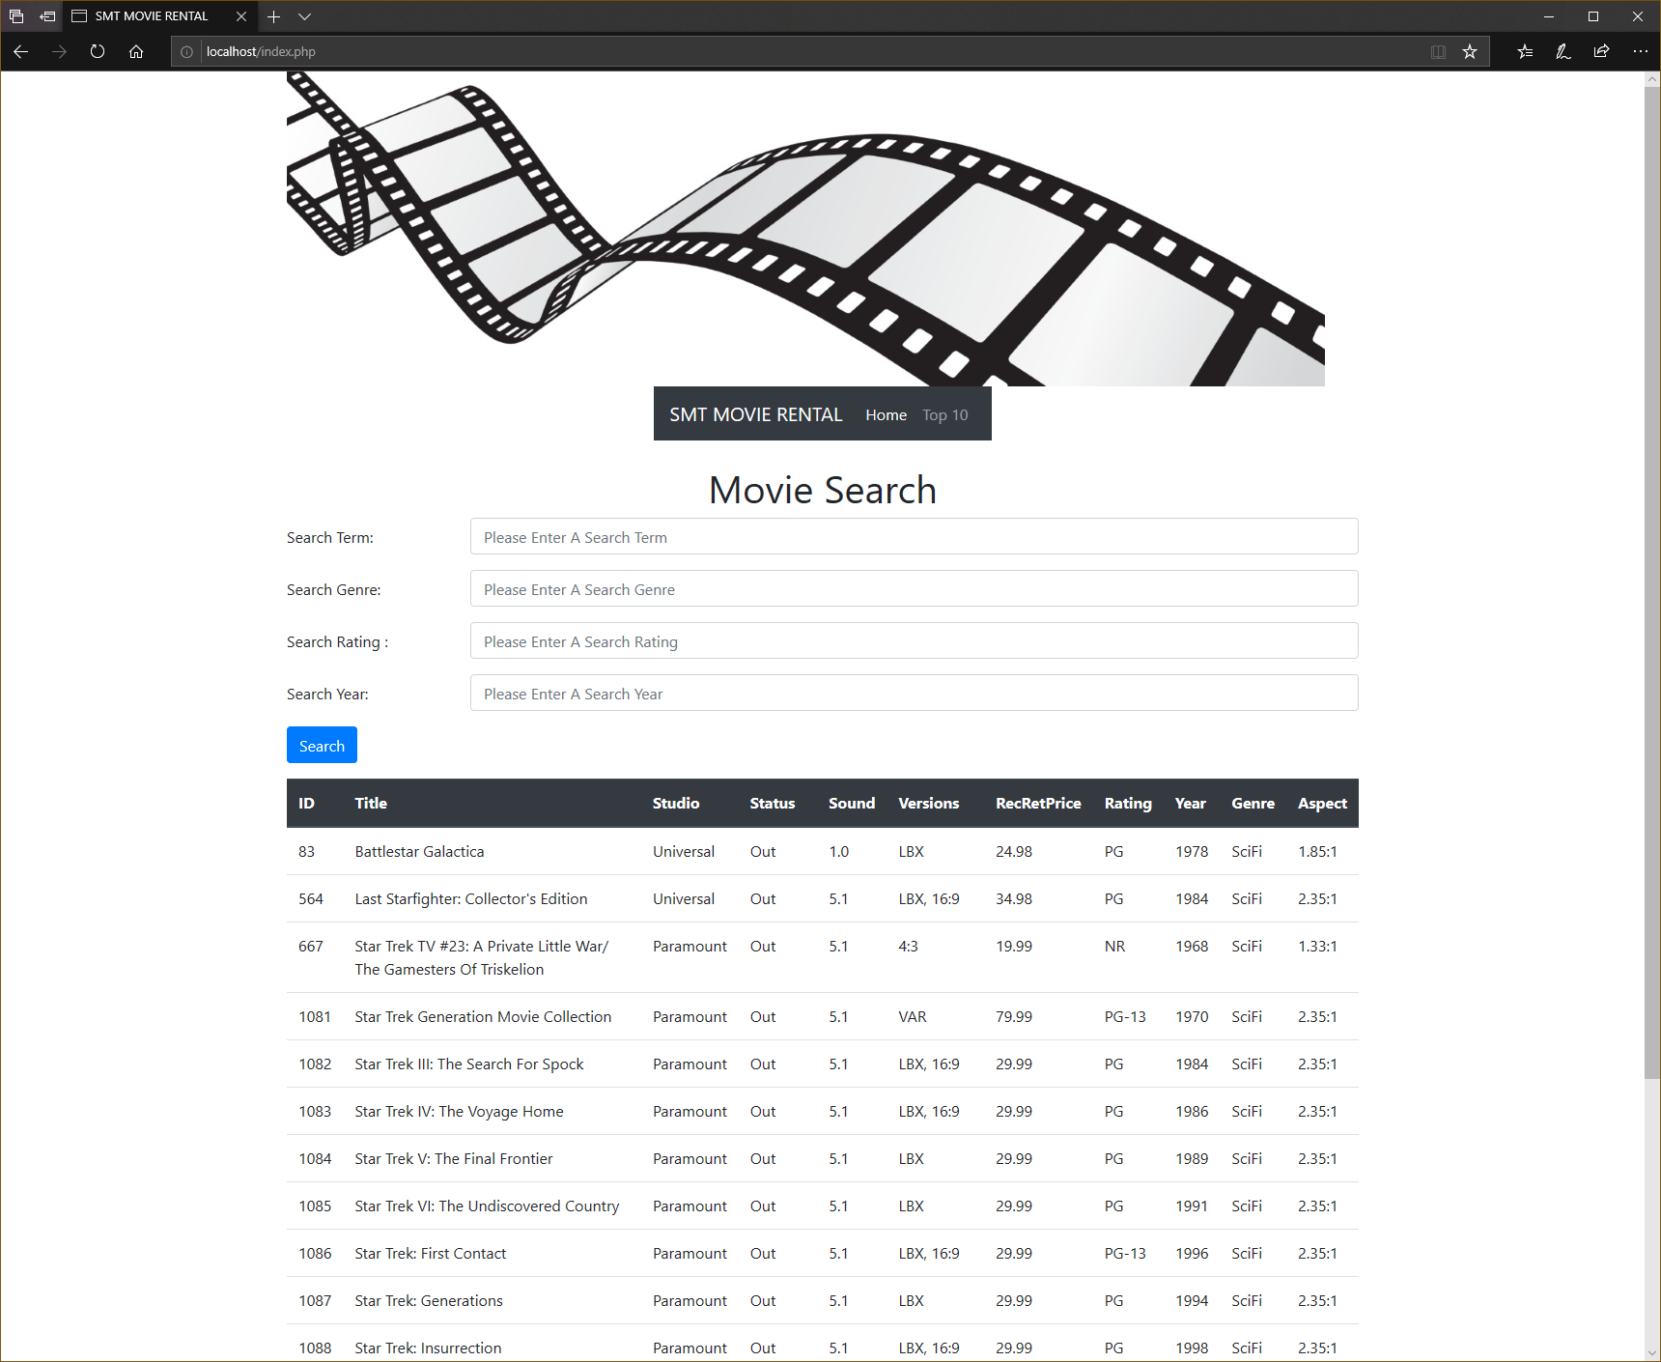

## Movie Not Found

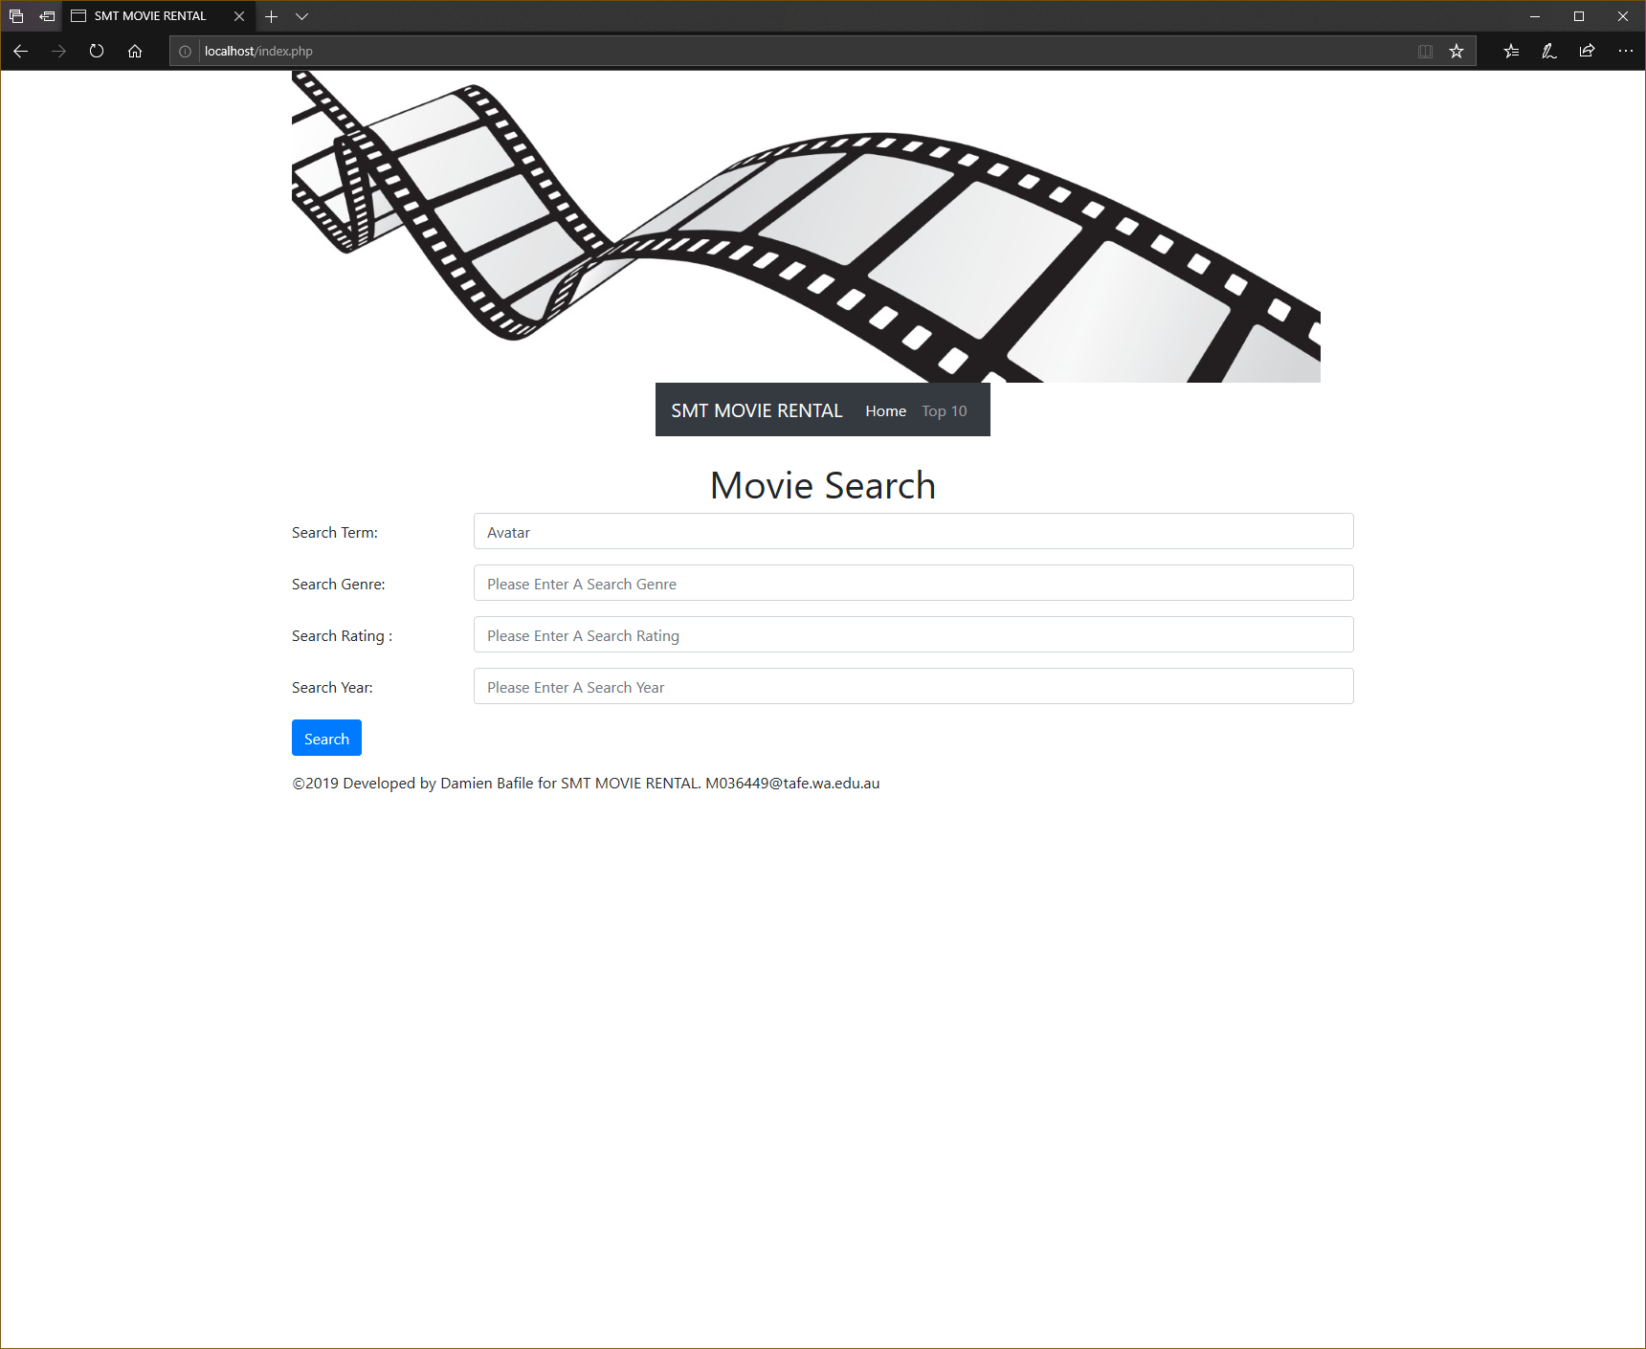 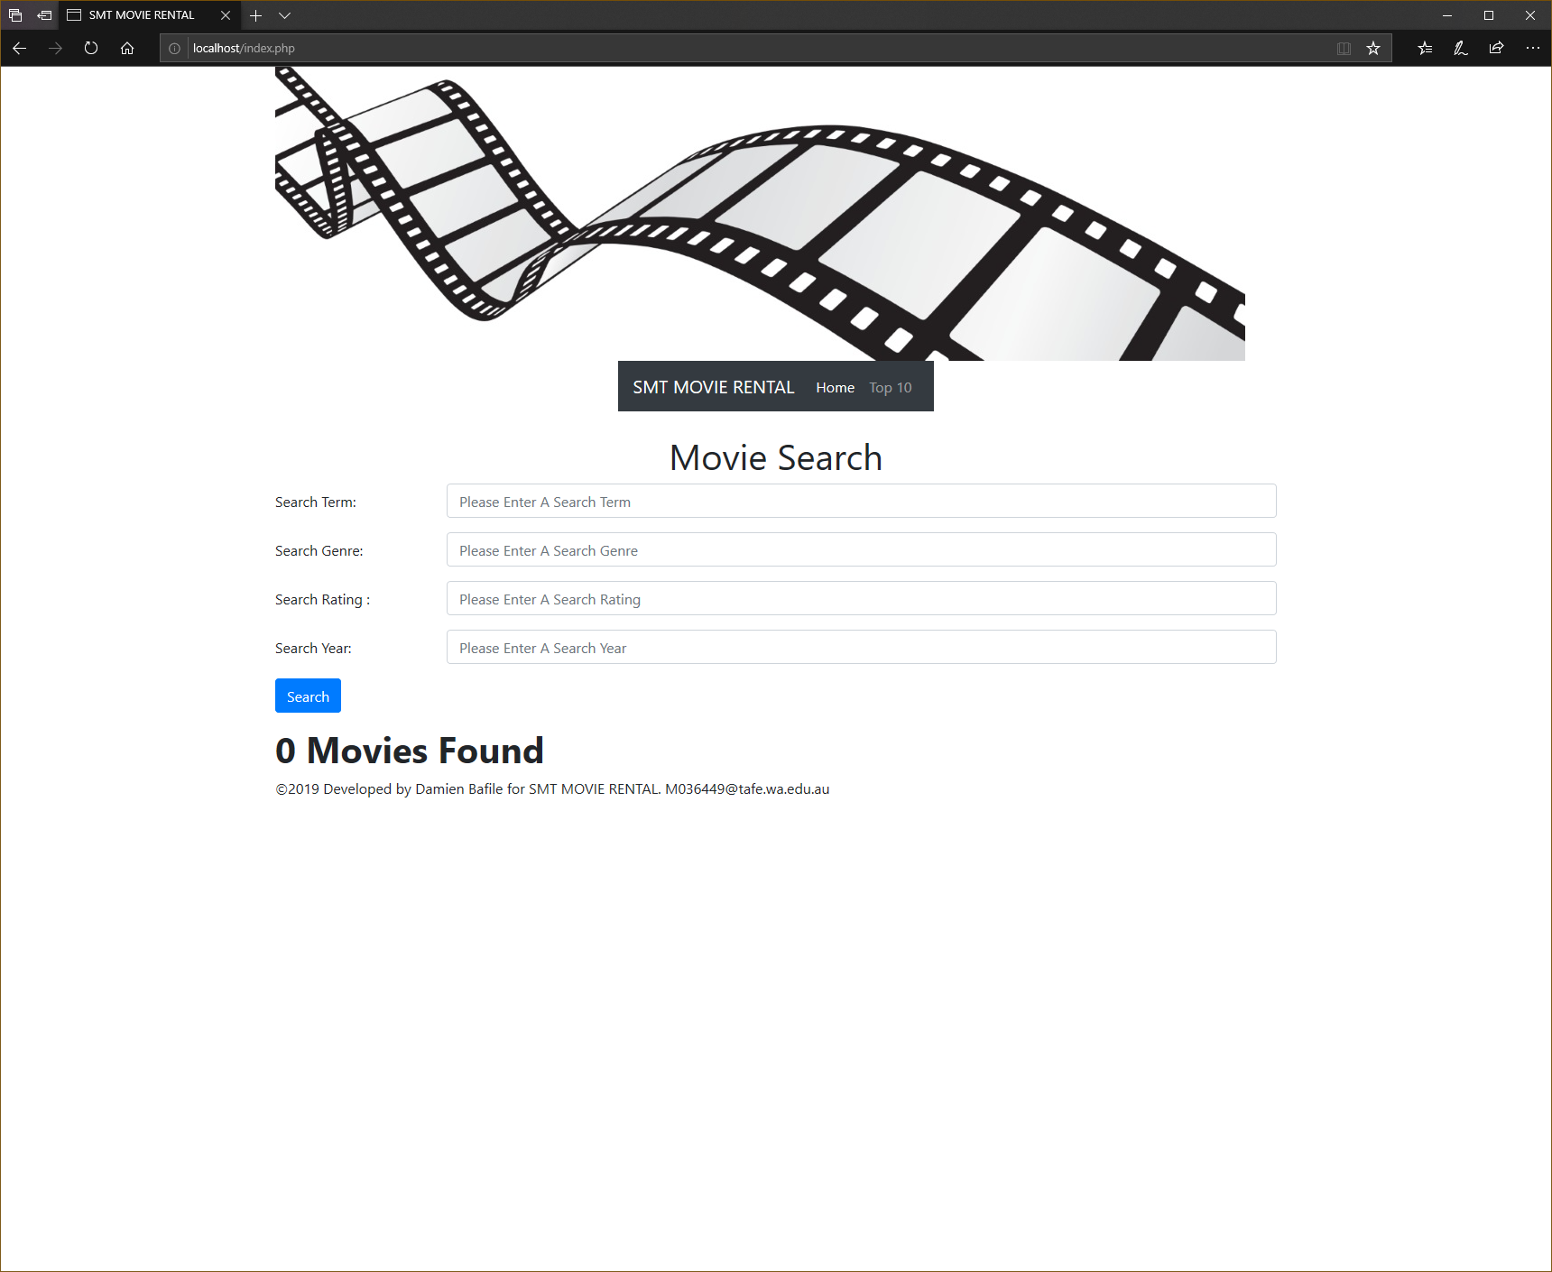

## Incorrect Search

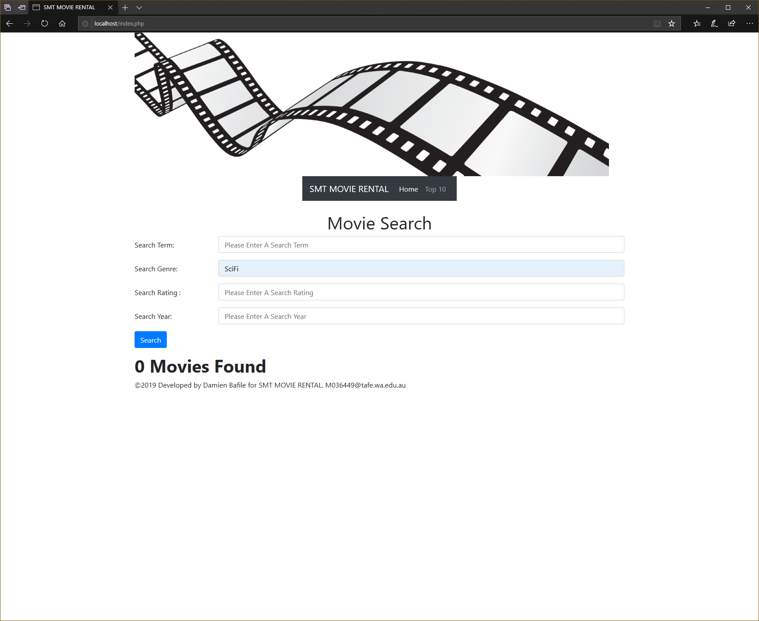 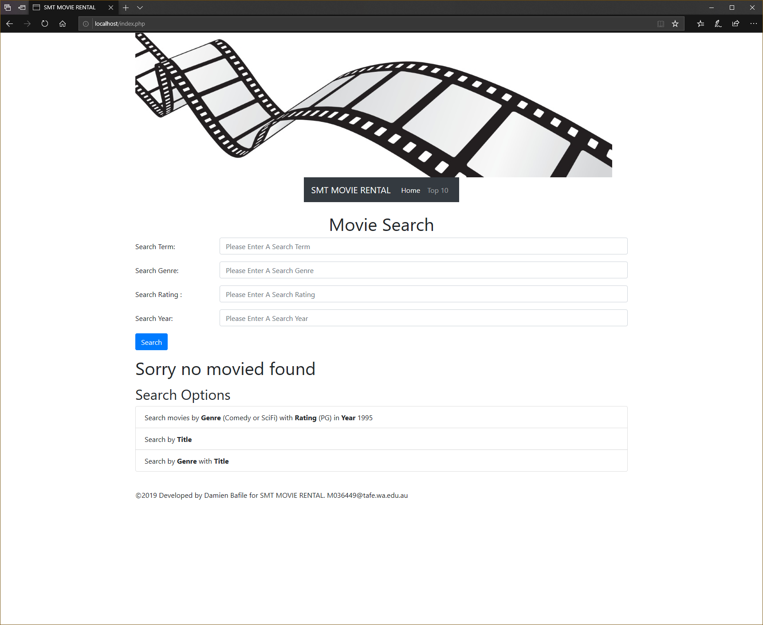

## Top 10 Search Movies

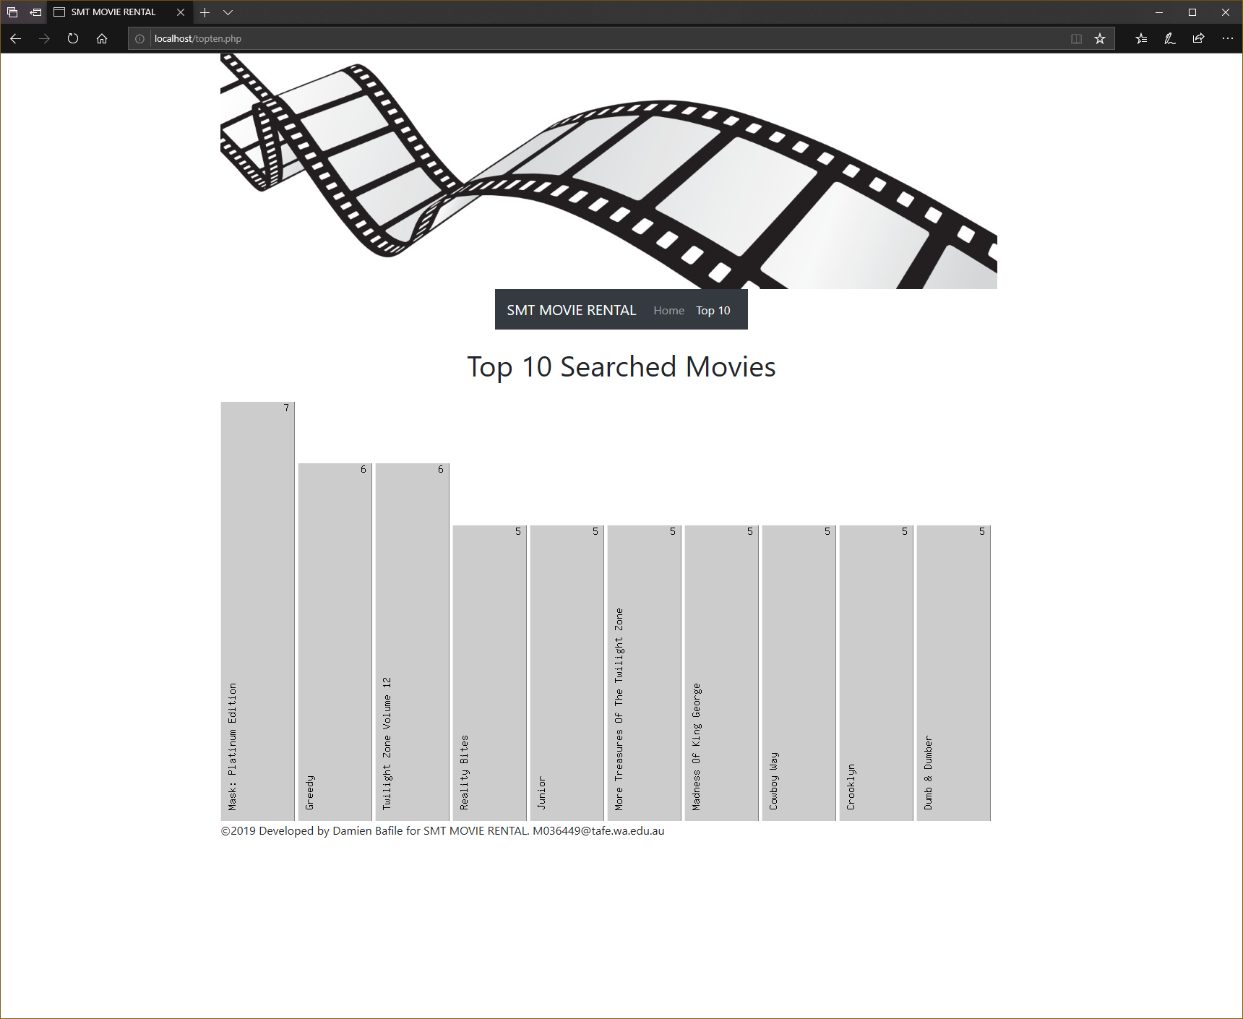

# Unexpected Behaviour?

As far as I can tell there is no unexpected behaviour.

# Are Requirements Completed?

# All listed requirements are completed though there are some security concerns

# Security issues?

The site is subject to SQL injections. User is “root” and there is no password so there is unlimited access to the database.

# Adjustments from testing.

I have some of the RegEx statements incorrect that I have adjusted